# ASSIGNMENT # 3 – MapReduce

Slide # 73

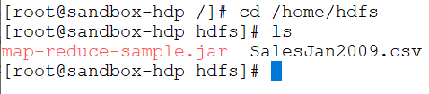

Slide # 74

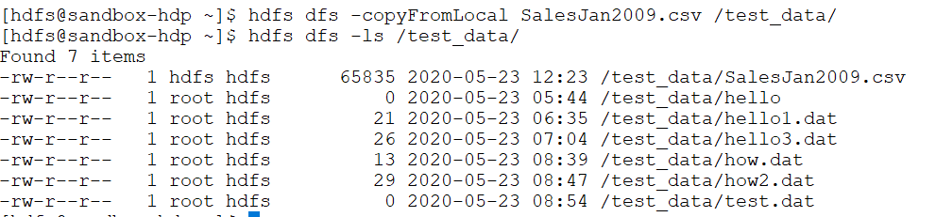

Slide # 75



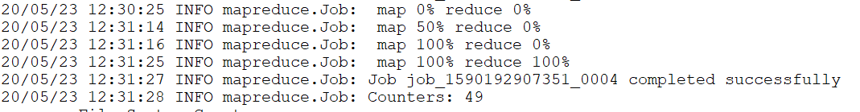

Slide # 76

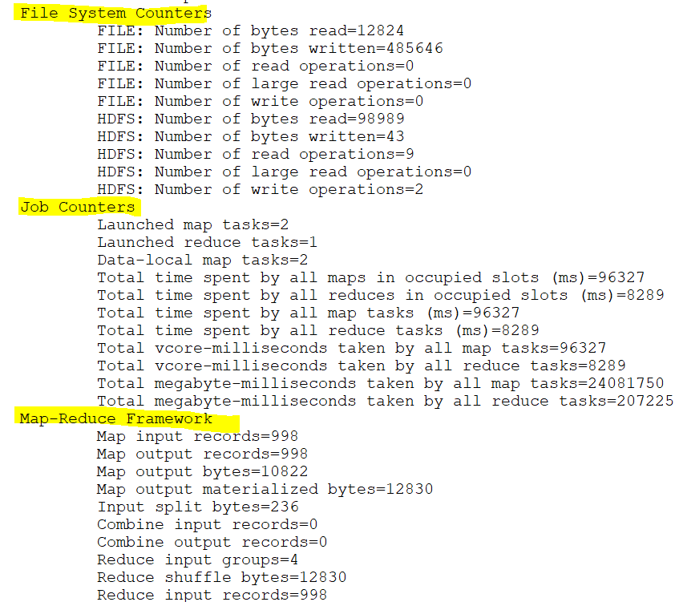

Slide # 77

